**Equity** **Research Report**

|  |  |  |  |  |  |
| --- | --- | --- | --- | --- | --- |
| **AMAZON** | | | **Rating -BUY [Price - $186.89]** | |  |
|  |  | |  | |  |
| **Target Price: $207.66** |  | **Date: 06/12/2024** | |

|  |  |  |  |  |  |  |
| --- | --- | --- | --- | --- | --- | --- |
| **About the Business** |  |  |  |  | **Company Snapshot** | |
| Amazon.com, Inc. is a multinational company that sells consumer products, offers advertising and subscription services through online and physical stores, and operates in North America and internationally. It has three main segments: North America, International, and Amazon Web Services (AWS). | | | | | Mkt Cap  P/E  Forward PE | 1.92T  51.41  40.83 |
|  | | | | |  |  |
| Amazon manufactures and sells electronic devices like Kindle and Echo, produces media content, and offers various programs for sellers and content creators. It provides cloud services, including computing, storage, and machine learning, as well as advertising services. Additionally, Amazon offers the Amazon Prime membership program. | | | | |  |  |
|  | | | | |  |  |
| The company serves a diverse customer base, including consumers, sellers, developers, enterprises, content creators, and advertisers. Founded in 1994, Amazon is headquartered in Seattle, Washington. | | | | |  |  |
| Amazon.com, Inc. is a multinational company that sells consumer products, offers advertising and subscription services through online and physical stores, and operates in North America and internationally. It has three main segments: North America, International, and Amazon Web Services (AWS). | | | | |  |  |
|  | | | | |  |  |
|  | | | | |  | |
| **Financial Snapshot** | **Mar-20** | **Mar-21** | **Mar-22** | **Mar-23** | **Shareholding Pattern** | |
| Revenue | 261,068 | 249,795 | 278,454 | 345,967 | Promoter | 46.37% |
| EBIT | (3336.65) | (2377.11) | 2308.45 | 13283.03 | FIIs | 18.62% |
| PBT | (10,580) | (10,474) | (7,003) | 3,058 | DIIs | 17.25% |
| TAX | 395 | 2,542 | 4,231 | 704 | Public  Govt. | 17.60%  0.14% |
| **NET PROFIT** | **(12,071)** | **(13,451)** | **(11,441)** | **2,414** |
| **Key Points**  1. Business Segments: North America, International, and Amazon Web Services (AWS). | | | | |  | |
|  | |
| 2. Products and Services: Retail sales (online and physical), electronic devices (Kindle, Fire tablets, Fire TVs, Echo, Ring, Blink, eero), media content production, Amazon Prime membership. | | | | |  |  |
|  | | | | |  |  |
| 3. Cloud Services: AWS offers computing, storage, database, analytics, and machine learning services. | | | | |  |  |
| 4. Advertising Services: Provides sponsored ads, display, and video advertising. | | | | |  |  |
| 5. Programs for Sellers and Content Creators: Platforms for third-party sellers, authors, publishers, musicians, filmmakers, Twitch streamers, skill and app developers. | | | | |  |  |
|  | | | | |  |  |

# Quarterly Performance -

*Key Changes Between Q4 2023 and Q1 2024:*

*1) Revenue and Profitability:*

*- Revenue: Decreased from $169.961 billion in Q4 2023 to $143.313 billion in Q1 2024.*

*- Net Income: Slightly decreased from $10.624 billion in Q4 2023 to $10.431 billion in Q1 2024.*

*2) Gross and Operating Margins:*

*- Gross Margin: Increased from 45.54% in Q4 2023 to 49.32% in Q1 2024.*

*- Operating Margin: Increased from 7.77% in Q4 2023 to 10.68% in Q1 2024*

*. Free Cash Flow:*

*- Free Cash Flow: Decreased significantly from $29.112 billion in Q4 2023 to $5.054 billion in Q1 2024.*

*3)Operating Expenses:*

*- Operating Expenses: Decreased from $64.199 billion in Q4 2023 to $55.373 billion in Q1 2024, with reductions across selling, general & administrative, research & development, and other operating expenses.*

***Key Recent Developments and Future Plans of Amazon***

*1. Revenue Growth and Financial Performance:*

*- For the quarter ending March 31, 2024, Amazon's revenue was $143.31 billion, marking a 12.53% year-over-year growth compared to $127.36 billion in Q1 2023*

*- The company's gross profit increased to $70.68 billion from $59.57 billion, reflecting continued strength in its core operations.*

*2. Technological Innovations:*

*- Amazon has rolled out over 13,500 custom electric delivery vans in the U.S., part of its broader effort to decarbonize its delivery fleet and enhance sustainability.*

*- The company is expanding its drone delivery program, aiming to integrate drones into its existing fulfillment network for ultra-fast deliveries. This initiative includes launching in new regions like Italy and the UK by the end of 2024.*

*3. Robotics and Automation:*

*- Amazon is investing heavily in robotic systems to improve efficiency and support workplace safety. This includes the introduction of new robots, Sequoia and Digit, which aid in handling packages and assisting employees.*

*- The company is also developing AI-powered inspection technology to ensure the safety and maintenance of its delivery vans, underscoring its commitment to leveraging AI for operational enhancements.*

*4. Future E-commerce Trend:*

*- Looking ahead, Amazon plans to integrate AI more deeply into its e-commerce operations. This includes using AI for personalized shopping experiences and enhancing product recommendations based on customer data.*

*- Augmented and virtual reality are expected to play a bigger role in Amazon's e-commerce strategy, providing immersive shopping experiences and detailed product visualization for customers.*

*These strategic moves and technological advancements indicate Amazon's ongoing commitment to innovation, sustainability, and improving customer and employee experiences.*

***Brands Owned by Amazon***

Amazon owns a diverse portfolio of brands, spanning various sectors including consumer electronics, apparel, food, and digital content. Here are some key brands owned by Amazon:

Consumer Electronics

1. Kindle: Amazon’s line of e-readers, designed for reading digital books and periodicals.

2. Fire: A series of tablets (Fire Tablets) and streaming devices (Fire TV) for media consumption.

3. Echo: Smart speakers integrated with Amazon’s virtual assistant, Alexa.

4. Ring: Smart home security products, including video doorbells and cameras.

5. Blink Affordable home security cameras and systems.

6. eero: Mesh Wi-Fi systems that enhance home internet connectivity.

Apparel and Fashion

1. Amazon Essentials: A private label offering a wide range of clothing basics and everyday items.

2. Goodthreads: Men’s apparel brand focusing on casual and business casual wear.

3. Lark & Ro: Women’s fashion brand offering stylish and affordable clothing.

4. Buttoned Down: Premium men’s dress shirts made with high-quality materials.

5. Mae: Women’s lingerie and athleisure brand.

6. Find Fashion-forward clothing and accessories for men and women, primarily available in Europe.

Grocery and Food

1. Whole Foods Market: A leading natural and organic foods supermarket chain acquired by Amazon in 2017.

2. Amazon Fresh: Grocery delivery and pickup service offering a wide selection of groceries.

3. 365 by Whole Foods Market: Private label brand offering high-quality products at competitive prices.

Digital and Media Content

1. Audible: Audiobook and spoken-word entertainment service.

2. Twitch: Live streaming platform primarily for video games and esports.

3. Amazon Music: Streaming service offering a vast library of music and podcasts.

4. Prime Video: Subscription video-on-demand service with a wide range of movies, TV shows, and original content.

5. IMDb TV (now Amazon Freevee): Ad-supported streaming service offering a selection of TV shows and movies.

Household and Personal Products

1. AmazonBasics: Private label brand offering a wide range of household goods, electronics, and everyday items.

2. Solimo: Private label brand providing household essentials, including groceries, health, and personal care products.

3. Presto!: Private label brand focused on household cleaning products, including paper towels and detergents.

Home and Lifestyle

1. Rivet: Modern furniture and home décor brand.

2. Stone & Beam: Home furnishings brand offering comfortable and durable furniture.

3. Wag: Amazon’s private-label pet food brand.

Beauty and Personal Care

1. Belei: Skincare brand offering products with high-quality ingredients.

2. Puracy: Premium household and personal care products.

## Geographical Diversification

Amazon, originally a humble online bookstore, has expanded its operations and geographical footprint extensively since its inception. Here's a breakdown of its geographical diversification:

1. United States: Amazon's home base, where it began as an online bookseller in Seattle, Washington. It has since expanded its operations to various states across the country.

2. Europe: Amazon has a significant presence in several European countries including the United Kingdom, Germany, France, Spain, Italy, and the Netherlands. It operates various services such as Amazon Prime, Amazon Web Services (AWS), and fulfillment centers across these regions.

3. Asia-Pacific: Amazon has been actively expanding in the Asia-Pacific region, particularly in India and Japan. In India, Amazon faces stiff competition from local e-commerce giants like Flipkart.

4. Middle East: Amazon entered the Middle Eastern market with the acquisition of Souq.com, a major e-commerce player in the region. It has since rebranded Souq.com to Amazon. ae, expanding its services in the UAE and neighboring countries.

5. Latin America: Amazon has been gradually expanding its presence in Latin America, with operations in countries like Brazil and Mexico. However, the e-commerce market in this region is still developing, and Amazon faces competition from local players.

6. Australia: Amazon launched its full retail offering in Australia in 2017, offering a range of products and services including Prime and fulfillment centers.

7. Canada: Amazon has a significant presence in Canada, offering its full range of services including Prime, AWS, and fulfillment centers.

Overall, Amazon's geographical diversification strategy involves establishing a presence in key markets worldwide, adapting its services to local preferences and regulations, and leveraging its infrastructure and logistics network to facilitate global expansion.

# Management's Voice

In 2024, the management voice of Amazon likely reflects a continued focus on innovation, customer obsession, and sustainability. Here's a speculative perspective:

As we navigate through 2024, our commitment to innovation remains steadfast. We're continuously pushing the boundaries of what's possible, leveraging cutting-edge technologies like artificial intelligence and machine learning to enhance the customer experience and drive operational efficiency.

Customer obsession remains at the core of everything we do. We understand that the key to our success lies in delivering exceptional value and convenience to our customers, and we're constantly striving to raise the bar even higher. Whether it's through faster delivery options, expanded product offerings, or personalized recommendations, we're dedicated to meeting and exceeding the evolving needs and expectations of our customers around the world.

But our commitment extends beyond just our customers. We recognize the importance of being good stewards of the environment and the communities in which we operate. That's why we're doubling down on our sustainability efforts, from reducing our carbon footprint and increasing energy efficiency to investing in renewable energy and sustainable packaging solutions. We believe that by prioritizing sustainability, we can create a better future for everyone.

As we look ahead, we're excited about the opportunities and challenges that lie ahead. We remain laser-focused on our long-term vision of being the Earth's most customer-centric company, and we're confident that by staying true to our principles and values, we'll continue to drive innovation, delight our customers, and make a positive impact on the world."

|  |  |  |  |  |  |
| --- | --- | --- | --- | --- | --- |
| ***Detailed Ratio Analysis*** |  | | | | |
| **Financial Ratios** | **Mar-20** | **Mar-21** | **Mar-22** | **Mar-23** |
| **Liquidity Ratio** |  |  |  |  |
| Current Ratio | 62% | 66% | 64% | 60% |
| Quick Ratio | 34% | 41% | 38% | 34% |
| Cash Ratio | 25% | 32% | 29% | 24% |
| **Solvency Ratio** |  |  |  |  |
| Debt to Equity | 2.01x | 2.57x | 3.29x | 2.96x |
| Debt to Capital | 0.67x | 0.72x | 0.77x | 0.75x |
| Financial Leverage | 5.15x | 6.18x | 7.38x | 7.38x |
| Debt to EBITDA | 6.90x | 6.71x | 5.40x | 3.52x |
| Interest Coverage | -0.46x | -0.29x | 0.25x | 1.30x |
| Debt to Asset | 0.39x | 0.42x | 0.45x | 0.40x |
| **Efficiency Ratio** |  |  |  |  |
| Inventory Turnover Ratio | 6.97x | 6.92x | 7.90x | 8.49x |
| Fixed Asset Turnover Ratio | 0.99x | 0.89x | 1.04x | 1.27x |
| Total Asset Turnover Ratio | 0.82x | 0.73x | 0.85x | 1.03x |
| **Profitability Ratio** |  |  |  |  |
| Return on Equity | -19% | -24% | -26% | 5% |
| Return on Capital Employed | -2% | -1% | 1% | 7% |
| Return on Assets | -3.77% | -3.94% | -3.48% | 0.72% |

|  |  |  |  |  |  |  |
| --- | --- | --- | --- | --- | --- | --- |
| ***DuPont Analysis*** |  | | | | | |
| **Financial Ratios** | **Mar-20** | **Mar-21** | **Mar-22** | **Mar-23** |  |
| **DUPONT for ROE**  PAT Margin | -5% | -5% | -4% | 1% |  |
| Total Asset Turnover | 0.82x | 0.73x | 0.85x | 1.03x |  |
| Financial Leverage Ratio | 5.15x | 6.18x | 7.38x | 7.38x |  |
| **Return on Equity** | **-19%** | **-24%** | **-26%** | **5%** |  |
| **DUPONT FOR ROA** | **Mar-20** | **Mar-21** | **Mar-22** | **Mar-23** |  |
| PAT MARGIN | -5% | -5% | -4% | 1% |  |
| Total Asset Turnover | 0.82x | 0.73x | 0.85x | 1.03x |  |
| **Return on Asset** | **-3.77%** | **-3.94%** | **-3.48%** | **0.72%** |  |

**The PAT margin increased by 121.19% for FY on a YoY Basis. The ROE also shows an increasing trend for the last 5 years.**

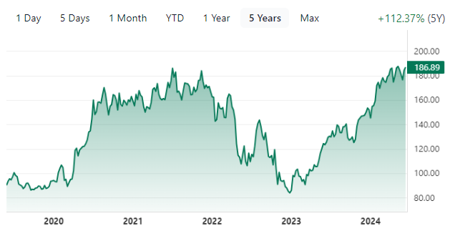

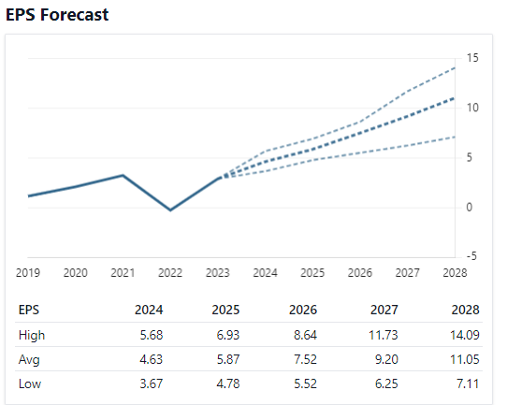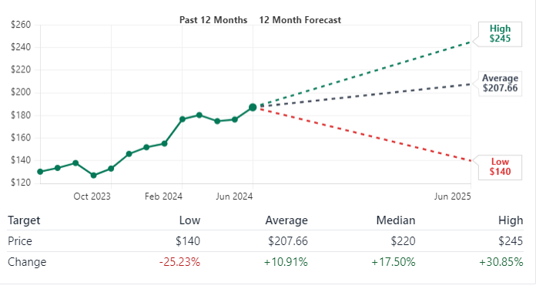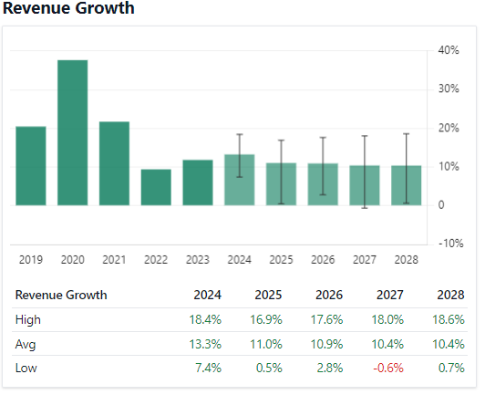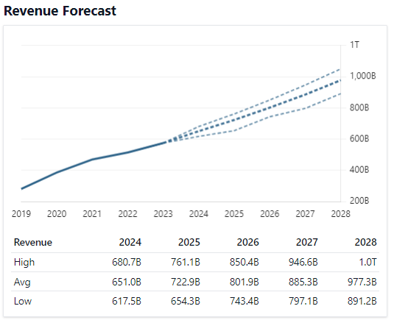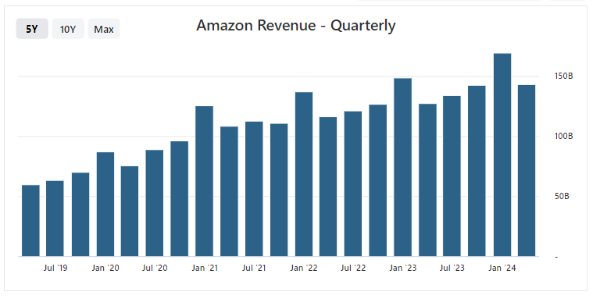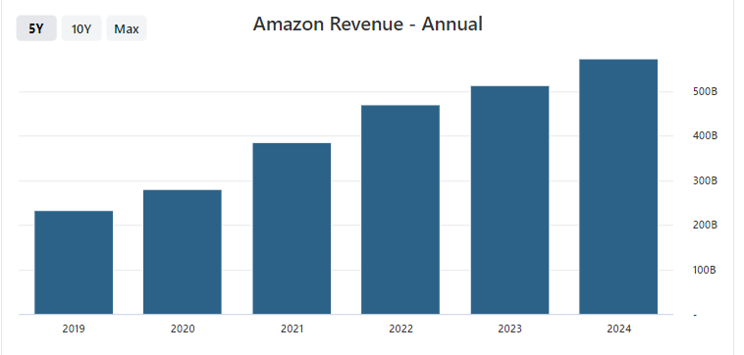

# Industry Overview

***Industry Overview of Amazon and the Tech Sector***

***Amazon Overview***

*1. E-commerce Dominance:*

*Market Leader: Amazon is a global leader in e-commerce, capturing a significant share of online retail sales. As of 2023, it held approximately 38% of the U.S. e-commerce market.*

*Product Range: The company offers a vast array of products, from consumer electronics and groceries to digital media and cloud services.*

*2. Cloud Computing with AWS:*

*Market Share: Amazon Web Services (AWS) is a dominant player in the cloud computing market, holding around 32% market share as of Q3 2023*

*Services: AWS provides a comprehensive suite of cloud services, including computing power, storage options, and machine learning capabilities, catering to startups, enterprises, and government agencies.*

*3. Technological Innovations:*

*AI and Robotics: Amazon integrates AI and robotics to enhance its logistics and delivery capabilities, including the development of custom electric delivery vans and advanced warehouse robots.*

*Drone Delivery: The company is actively expanding its drone delivery services, aiming for faster and more efficient package deliveries*

*4. Financial Performance:*

*Revenue Growth: For Q1 2024, Amazon reported revenue of $143.31 billion, a 12.53% increase year-over-year*

*Profit Margins: The company's gross profit and operating margins have shown improvement, reflecting its strong operational efficiency.*

***Tech Sector Overview***

*1. Industry Size and Growth:*

*Market Size The global technology industry is massive, with a market size exceeding $5 trillion as of 2023. It is expected to grow further due to advancements in AI, cloud computing, and IoT.*

*Investment in R&D: Tech companies are major investors in research and development, driving innovations in various fields including semiconductors, AI, and 5G technology.*

*2. Key Trends:*

*Artificial Intelligence: AI continues to revolutionize industries, providing significant advancements in automation, data analysis, and customer experience.*

*Cloud Computing: Cloud services are becoming essential for businesses of all sizes, with major providers like AWS, Microsoft Azure, and Google Cloud leading the market.*

*Cybersecurity: As digital transformation accelerates, the need for robust cybersecurity measures grows, with increasing investments in this area to protect data and privacy.*

*3. Major Players:*

*Big Tech: Companies like Amazon, Google, Microsoft, and Apple dominate the tech landscape, each leading in various sectors from cloud computing to consumer electronics.*

*Innovative Startups: The tech sector also sees a continuous influx of innovative startups, particularly in areas like fintech, health tech, and edtech, contributing to dynamic industry growth.*

*4. Regulatory Environment:*

*Antitrust and Data Privacy: Governments worldwide are increasing scrutiny of big tech companies regarding antitrust issues and data privacy regulations. This includes ongoing investigations and potential regulations aimed at curbing monopolistic practices and ensuring user data protection.*

*Conclusion*

*Amazon remains a pivotal player in both the e-commerce and cloud computing markets, continually expanding its technological capabilities and market reach. The broader tech sector is characterized by rapid growth, innovation, and significant investment in emerging technologies, all of which contribute to its dynamic and transformative nature.*